Confidence Intervals: Practice 3;
Confidence Intervals for Proportions

Student Learning Outcomes:

- The student will explore the properties of the confidence intervals for proportions.

Given:
The Ice Chalet offers dozens of different beginning ice-skating classes. All of the class names are put into a bucket. The 5 P.M., Monday night, ages 8 - 12, beginning ice-skating class was picked. In that class were 64 girls and 16 boys. Suppose that we are interested in the true proportion of girls, ages 8 - 12, in all beginning ice-skating classes at the Ice Chalet.

Estimated distribution

1. What is being counted?

2. In words, define the Random Variable X.
X = _____________________________________________________________

3. Calculate the following:
a. x = __________
b. n = __________
c. p' = __________

4. State the estimated distribution of X. X ~ ____________________

5. Define a new Random Variable P'. What is p' estimating?

6. In words, define the Random Variable P'.
P' = ______________________________________________________________

- State the estimated distribution of P'. P' ~ ____________________

Explaining the Confidence Interval

Construct a 92% Confidence Interval for the true proportion of girls in the age 8 - 12 beginning ice-skating classes at the Ice Chalet.

8. How much area is in both tails (combined)? α = __________

9. How much area is in each tail? 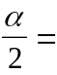 __________

10. Calculate the following:
a. lower limit = ________
b. upper limit = ________
c. error bound = ________

11. The 92% Confidence Interval is: ____________________________

12. Fill in the blanks on the graph with the areas, upper and lower limits of the Confidence Interval, and the sample proportion.

______ C.L. = ______ ______
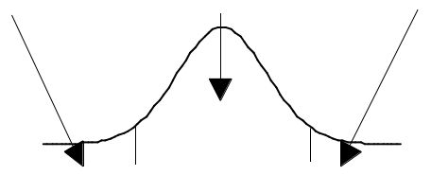

____ ____ ____ P'

13. In one complete sentence, explain what the interval means.

Discussion Questions

1. Using the same p' and level of confidence, suppose that n were increased to 100. Would the error bound become larger or smaller? How do you know?

2. Using the same p' and n = 80, how would the error bound change if the confidence level were increased to 98%? Why?

3. If you decreased the allowable error bound, why would the minimum sample size increase (keeping the same level of confidence)?

